Introductory Economics for Business and Finance (IC103)

Tutorial 1 Solutions

- Which of the following would NOT be a determinant of demand?
  - The price of related goods
  - Income
  - Tastes
  - The prices of inputs used to make the good
Anything that affects a consumer can affect their demand for any product.
Suppose that good A is the main good under consideration.
In the case of (a) if the price of a substitute B falls, it will become more attractive relative to good A, so the demand curve for good A will shift to the left.
If the price of a complement B falls, then the demand curve for good A will shift to the right as the consumption demand for both goods at each price level will increase.
For option (b), for a normal good, an increase in income shifts demand to the right. (we can consume more than previously).
Finally, (c) refers to preferences. If something becomes more popular then its demand will increase, and the demand curve shifts to the right.

- Which of the following would cause a commodity supply curve to shift to the LEFT?
  - An increase in labour input costs
  - An improvement in production techniques
  - A fall in production costs
  - A fall in consumers’ incomes
Anything which makes it more costly to produce a good will shift the supply curve to the left, therefore (a) is the correct answer.
If production techniques improve, this will shift the supply curve to the right as will a fall in production costs.
A fall in incomes affects demand, not supply.

- When the price is higher than the equilibrium price
  - There will be a shortage
  - Buyers would like to buy more than is produced
  - Sellers would like to produce and sell more than buyers would like to purchase
  - Quantity demanded equals quantity supplied
This is best explained using the diagram below.

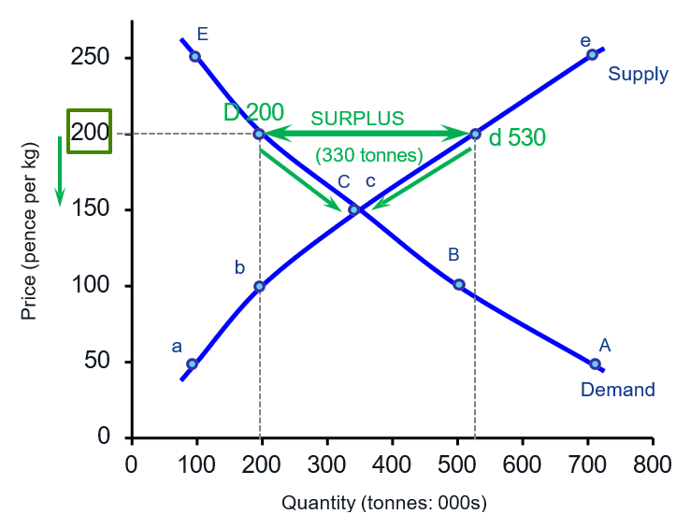
The equilibrium price is the price where quantity demanded equals quantity supplied. At this price, everything that firms want to sell can be bought by consumers.
If the price is higher than the equilibrium price, two things happen:
- Consumers want to buy less, because the product is more expensive.
- Producers want to sell more, because the higher price makes production more attractive.
Therefore, quantity supplied becomes greater than quantity demanded. This creates a surplus, also called excess supply.
In the diagram, the equilibrium is at point C, where demand and supply are equal. If the price increases to 200, consumers demand about 200, while producers supply about 530. This creates a surplus of 330.
Because firms cannot sell everything they have produced, they will normally start reducing the price. As the price falls, consumers buy more and producers supply less, until the market moves back towards the equilibrium price.

- When there is a shortage in a market,
  - There is downward pressure on price
  - There is upward pressure on price
  - The market could still be in equilibrium
  - The price must be above the equilibrium value
Shortage means that the quantity demanded is greater than quantity supplied. (i.e., excess demand).
Whenever there is excess demand the price of the good will increase.
Therefore, (b) is the right answer.

- If buyers expect the price of a good to rise in the future, the result is:
  - A decrease in the supply today
  - An increase in the supply today
  - A decrease in the quantity demanded today
  - An increase in demand today
This is related to the expectations of consumers.
If there are expectations of higher prices in the future, the consumers will try to consume more today and less in the future (i.e., avoid higher prices in the future). So, answer (d) is the correct one.
Note that the question states only what is believed by buyers, therefore the effect has to be related with the demand curve. Thus, answers (a) and (b) are rejected right away.
Also, (c) is about a movement along the curve, which can only happen because the current price changes.

- The table below shows the daily demand and supply schedule for university branded beanie hats.

Price | Quantity demanded | Quantity supplied
£10 | 10 | 100
£8 | 20 | 80
£6 | 30 | 60
£4 | 40 | 40

If the price were £8,
  - There would be a surplus of 30 hats and price would tend to fall
  - There would be a surplus of 60 hats and price would tend to rise
  - There would be a surplus of 60 hats and price would tend to fall
  - There would be a shortage of 30 hats and price would tend to rise
With a price of 8, 20 are demanded and 80 are supplied so there is a surplus of 60.
Since supply exceeds demand, the price would tend to fall.
Thus, the correct answer is (c).
- The weekly demand and supply of tomatoes is shown below:

Price per kg (£) | 4.00 | 3.50 | 3.00 | 2.50 | 2.00 | 1.50 | 1.00
QD (000 kg) | 30 | 35 | 40 | 45 | 50 | 55 | 60
QS (000 kg) | 80 | 68 | 62 | 55 | 50 | 45 | 38

  - What are the equilibrium price and quantity?
This can be read from the table.
At a price of £2 the quantity demanded is the same as the quantity supplied - 50,000 kg.

  - What would happen if the government fixed the minimum price per kg at (i)
£3 or (ii) £1.5?

If the government sets a minimum price of £3 there will be excess supply of 22,000 kg.

Given that this is a minimum price, it cannot fall to clear the market.

With a minimum of £1.50 there will be excess demand of 10,000 kg but given that this is a minimum price it can rise to clear the market.

- If the demand (D) and supply (S) curves for computers can be shown as:
𝐷 = 100 − 6𝑃
and
𝑆 = 28 + 3𝑃
Where 𝑃 is price. What quantity of computers will be bought and sold at equilibrium?

We know that the equilibrium occurs where quantity demanded is the equal to the quantity supplied.

Hence, setting $D=S$ gives us $100 - 6P = 28 + 3P$which can be re-arranged to:
$$100 - 28 = 9P,$$
or
$72 = 9P$,
which means that $P = 8.$

At a price of £8, demand (supply) is equal to

$100-6*8=100-48 =52$ computers.
or
$28+3*8=28+24=52$ computers.

- Consider the demand curve for petrol. What effect will each of the following have?
  - An increase in the price of cars

A higher price of cars causes a movement along the demand curve for cars to a lower quantity demanded.

Because cars and petrol are complementary goods, fewer cars being used reduces the demand for petrol, shifting the petrol demand curve to the left.

  - An increase in the car-owning population

This means more petrol is needed so the demand curve shifts to the right.

  - A rise in the transport cost of shipping oil

A rise in transport costs makes it more expensive for firms to supply petrol. This increases the cost of production and causes the supply curve for petrol to shift to the left.

As a result:
- the equilibrium price of petrol increases;
- the equilibrium quantity of petrol decreases;
- the demand curve does not shift.

Consumers buy less petrol because the price is now higher. This is a movement along the demand curve, rather than a shift in the demand curve.

  - A growing concern about environmental issues

This means people will switch to public transport/walking/cycling so they will demand less petrol at all prices, so the demand curve shifts
to the left.

  - The removal of taxes on electric cars

This will make them cheap relative to conventional cars, reducing demand for petrol, so the result is as in (d). The demand curve shifts to the left.

- Consider the following estimated demand and supply equations for a software programme:

𝑄_{𝐷} = 348 − 4𝑃 + 0.15𝑌
𝑄_{𝑆} = 600 + 100𝑃

Where:
QD= quantity demanded QS=quantity supplied
𝑃=price
𝑌= income

  - Is the market in equilibrium if the price is £12 and income is £10,000?

In this case

QD$=348-4*12+0.15*10,000=1,800$
QS=$600+100*12=1,800$

so we have equilibrium

  - If income rises by 5% will this lead to a shortage or surplus?

Notice that only demand is affected.

𝑄_{𝐷} becomes 348 − 4 ∗ 12 + 0.15 ∗ 10,500 = 1,875.

$$Q_{D}=1,875$$
$$Q_{S}=1,800$$

So, there is a shortage of $1,875 - 1,800 = 75$ units.

  - What is the new equilibrium price?

Once again there is an equation to solve:

𝑄_{𝐷} = 𝑄_{𝑆}
or
348 − 4𝑃 + 0.15 ∗ 10,500 = 600 + 100 ∗ 𝑃
348 + 1,575 − 600 = 104 ∗ 𝑃
𝑃 = £12.72

